```[1]

( 16pt )

**Title in English ( 16pt Bold)**

( 9pt )

**G. D. Hong*,a, H. S. Leeb, and Young_Sil Jangc ( 9pt Bold )**

( 10pt )

a *Hankuk University, Seoul, Korea ( 9pt italic )*

b *Korea Institute for Superconductivity, Pusan, Korea*

c *Superconductivity Research Center, Daejeon, Korea*

( 10pt )

(Received 1 March 1999; revised or reviewed 15 March 1999; accepted 1 April 1999) (9pt Normal)

(10pt double space)

**Abstract (9pt Bold)**

(9pt)

The Progress in Superconductivity is published every four months and serves as a channel for publications on superconductivity and related topics. The author(s) are required to submit THREE copies of the manuscripts along with original figures directly to the Editor. ( 9pt )

(9pt )

*Keywords ( 8pt italic )* : Magnetoconductance ( 8pt Normal )

(8pt double space)

**1. INTRODUCTION (10pt Bold**

(10 pt)

This document is a template for Microsoft *Word* versions 6.0 or later. Margins are as follows. Top : 20 mm; bottom : 20 mm; left : 20 mm; right : 20 mm; head : 5mm; tail : 5 mm. Font : Times New Roman, the size is 10 pt. Line spacing : single.

Type over sections of TEMPLATE.DOC or cut from another document and paste and then use markup styles. The pull-down style menu is at the left of the Formatting Toolbar at the top of your *Word* window (for example, the style at this point in the document is "Text"). Highlight a section that you want to designate with a certain style, and then select the appropriate name on the style menu. The style will adjust your fonts and line spacing. Do not change the font sizes or line spacing to squeeze more text into a limited number of pages.

(10pt Double Space)

**2. HELPFUL HINTS**

2.1. Figures and Tables

Large figures and tables may span both columns. Place figure captions below the figures; place table titles above the tables. If your figure has two parts, for example, include the labels "(a)" and "(b)" as part of the artwork. Please verify that figures and tables that you mention in the text actually exist.

Use the abbreviation "Fig." even at the beginning of a sentence. Do not abbreviate "Table." Tables are numbered with Roman numerals.

Figure axis labels are often a source of confusion. Use words rather than symbols. As an example, write the quantity "Magnetization," or "Magnetization, *M*," not just

|  |
| --- |
| **\*** Corresponding author: gdhong@hankuk.ac.kr |

TABLE

Units for Magnetic Properties.

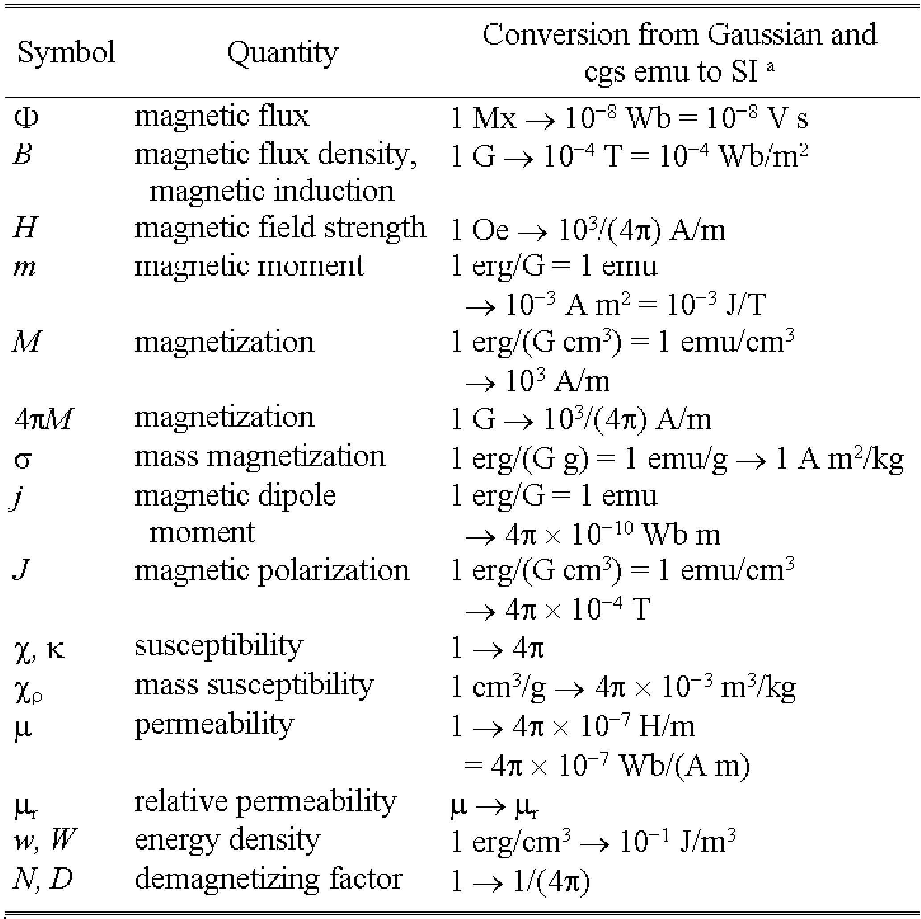

No vertical lines in table. Statements that serve as captions for the entire table do not need footnote letters.

"*M*." Put units in parentheses. Do not label axes only with units. As in Fig. 1, for example, write "Magnetization (A/m)" or "Magnetization (Am)," not just "A/m." Do not label axes with a ratio of quantities and units. For example, write "Temperature (K)," not "Temperature/K." Multipliers can be especially confusing. Write "Magnetization (kA/m)" or "Magnetization (A/m)." Figure labels should be legible, approximately 8 to 10 point type.

2.2. References

Number citations consecutively in square brackets [1]. The sentence punctuation follows the brackets [2]. Multiple references [2, 3] are each numbered with separate brackets [1-3]. When citing a section in a book, please give the relevant page numbers [2]. In sentences, refer simply to the reference number, as in [3]. Do not use "Ref. [3]" or "reference [3]" except at the beginning of a

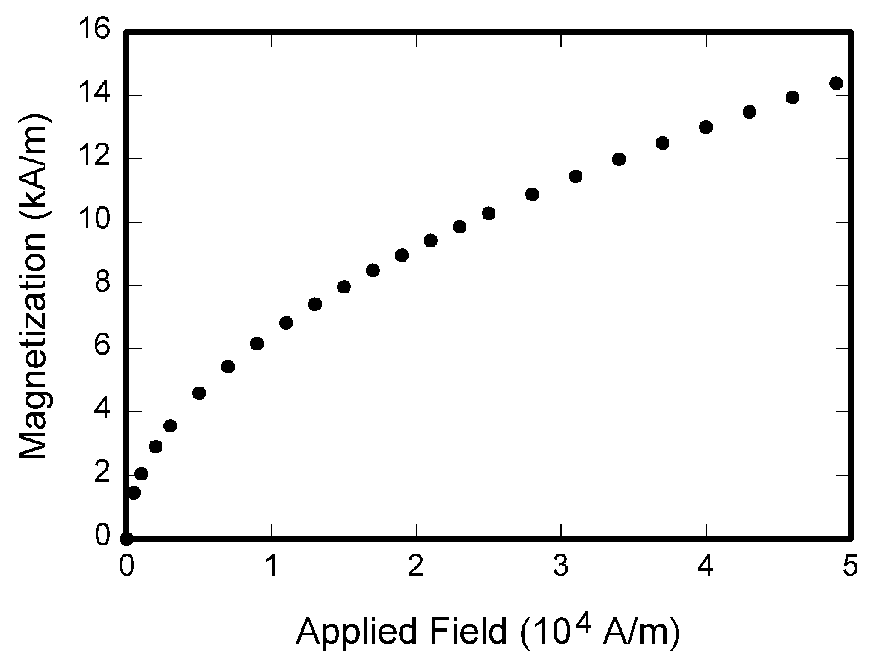

Fig. 1. Magnetization as a function of applied field. Note that "Fig." is abbreviated. There is a period after the figure number, followed by two spaces. It is good practice to explain the significance of the figure in the caption**.**

sentence: "Reference [3] shows ... ."

2.2.1 Other References

Give all authors' names; do not use "et al." unless there are six authors or more. Use a space after authors' initials. Papers that have not been published should be cited as "unpublished" [4]. Papers that have been submitted or accepted for publication should be cited as "submitted for publication" [5]. Please give affiliations and addresses for personal communications [6].

Capitalize only the first word in a paper title, except for proper nouns and element symbols. If you are short of space, you may omit paper titles. However, paper titles are helpful to your readers and are strongly recommended. For papers published in translation journals, give the English citation first, followed by the original foreign-language citation [7].

2.3. Abbreviations and Acronyms

Define abbreviations and acronyms the first time they are used in the text, even after they have already been defined in the abstract. Abbreviations such as PSAC , SI, ac, and dc do not have to be defined. Abbreviations that incorporate periods should not have spaces: write "P.S.A.C.," not "P. S. A. C." Do not use abbreviations in the title unless they are unavoidable.

2.4. Equations

Number equations consecutively with equation numbers in parentheses flush with the right margin, as in (1). First use the equation editor to create the equation. Then select the "Equation" markup style. Press the tab key and write the equation number in parentheses. To make your equations more compact, you may use the solidus ( / ), the exp function, or appropriate exponents. Use parentheses to avoid ambiguities in denominators. Punctuate equations when they are part of a sentence, as in

 (1)

Be sure that the symbols in your equation have been defined before the equation appears or immediately following. Refer to "(1)," not "Eq. (1)" or "equation (1)," except at the beginning of a sentence: "Equation (1) is ... ."

2.5. Other Recommendations

Use one space after periods and colons. Hyphenate complex modifiers: "zero-field-cooled magnetization."

Use a zero before decimal points: "0.25," not ".25." Use "cm," not "cc." Indicate sample dimensions as "0.1 cm  0.2 cm," not "0.10.2 cm." The abbreviation for "seconds" is "s," not "sec." Do not mix complete spellings and abbreviations of units: use "Wb/m" or "webers per square meter," not "webers/m." When expressing a range of values, write "7 to 9" or "7-9," not “7~9.”

A parenthetical statement at the end of a sentence is punctuated outside of the closing parenthesis (like this). (A parenthetical sentence is punctuated within the parentheses.) In American English, periods and commas are within quotation marks, like "this period." Other punctuation is "outside"! If you wish, you may write in the first person singular or plural and use the active voice ("I observed that ..." or "We observed that ..." instead of "It was observed that ...").

**ACKNOWLEDGMENT**

The preferred spelling of the word "acknowledgment" in American English is without an "e" after the "g." Use the singular heading even if you have many acknowledgments. Avoid the expression, "One of us (S.B.A.) thanks...." Instead, write "S.B.A. thanks...." Put sponsor acknowledgments in the unnumbered footnote on the first page.

**REFERENCES**

1. G. Eason, B. Noble, and I. N. Sneddon, "On certain integrals of Lipschitz-Hankel type involving products of Bessel functions*," Phil. Trans. Roy. Soc.* London, vol. A247, pp. 529-551, Apr. 1955.
2. J. Clerk Maxwell, *A Treatise on Electricity and Magnetism,* 3rd ed., vol. 2. Oxford: Clarendon, 1892, pp. 68-73.
3. I. S. Jacobs and C. P. Bean, "Fine particles, thin films and exchange anisotropy," in *Magnetism,* vol. III, G. T. Rado and H. Suhl, Eds. New York: Academic, 1963, pp. 271-350.
4. K. Elissa, "Title of paper," unpublished.
5. R. Nicole, "Title of paper with only first word capitalized," *J. Name Stand. Abbrev.,* submitted for publication.
6. C. J. Kaufman, Rocky Mountain Research Laboratories, Boulder, CO, personal communication, 1992.
7. Y. Yorozu, M. Hirano, K. Oka, and Y. Tagawa, "Electron spectroscopy studies on magneto-optical media and plastic substrate interface," *IEEE Transl. J. Magn. Jpn.,* vol. 2, pp. 740-741, August 1987 [*Dig. 9th Annual Conf. Magn. Jpn.,* p. 301, 1982].
8. M. Young, *The Technical Writer's Handbook.* Mill Valley, CA: University Science, 1989.

1.